A project Report On

Travel Agency Website

Name: Pratik Ramesh Taye

Type of Project : web technology

Technology : HTML5,CSS3,BOOTSTRAP5 &

JAVASCRIPT

Date Of Submission: 16-10-2024

1. Overview :

"Travel with Pratik" is a travel agency website designed to offer personalized travel experiences. It provides a range of services, including tailored itineraries, booking assistance, and expert travel advice. The agency focuses on customer satisfaction, ensuring that each trip is unique and memorable. Users can explore various travel packages, read blog posts for inspiration, and easily contact the agency for inquiries or bookings. The site aims to cater to diverse travel preferences, whether for adventure, relaxation, or cultural exploration.

1. Objectives :

The objectives of the "Travel with Pratik" travel agency website include:

1. Personalized Travel Experiences: To provide customized itineraries that cater to individual preferences and interests.

2. Customer Satisfaction: To ensure a high level of satisfaction by offering excellent customer service and support throughout the travel planning process.

3. Diverse Offerings : To offer a wide range of travel packages, including adventure, relaxation, and cultural experiences.

4. Expert Guidance : To provide expert travel advice and tips to help clients make informed decisions about their trips.

5. User-Friendly Experience : To create an intuitive and easy-to-navigate website that facilitates booking and inquiries.

6. Inspiration and Education : To inspire travelers through engaging blog content and destination guides.

7. Building Relationships : To foster long-term relationships with clients, encouraging repeat business and referrals.

1. Key Features :

### **Home**

* **Welcome Banner**: Eye-catching visuals with a brief introductory message.
* **Featured Images**: Highlight to traveling experience or collections to draw visitors in.
* **Quick Navigation**: Easy links to the Gallery, Services, About, and Team sections.

### **About**

* **Personal Story**: Share your background and passion for Travel experience
* **Mission Statement**: Clearly define your goals and values.
* **Professional Background**: Highlight your experience, education, and achievements.

### **Services**

* **Service Descriptions**: Detail the tour services you offer .
* **Pricing Information**: e a transparent overview of pricing or package options.
* **Booking Form**: Easy-to-use form for inquiries and bookings.

4 .Output Screens :

Home page

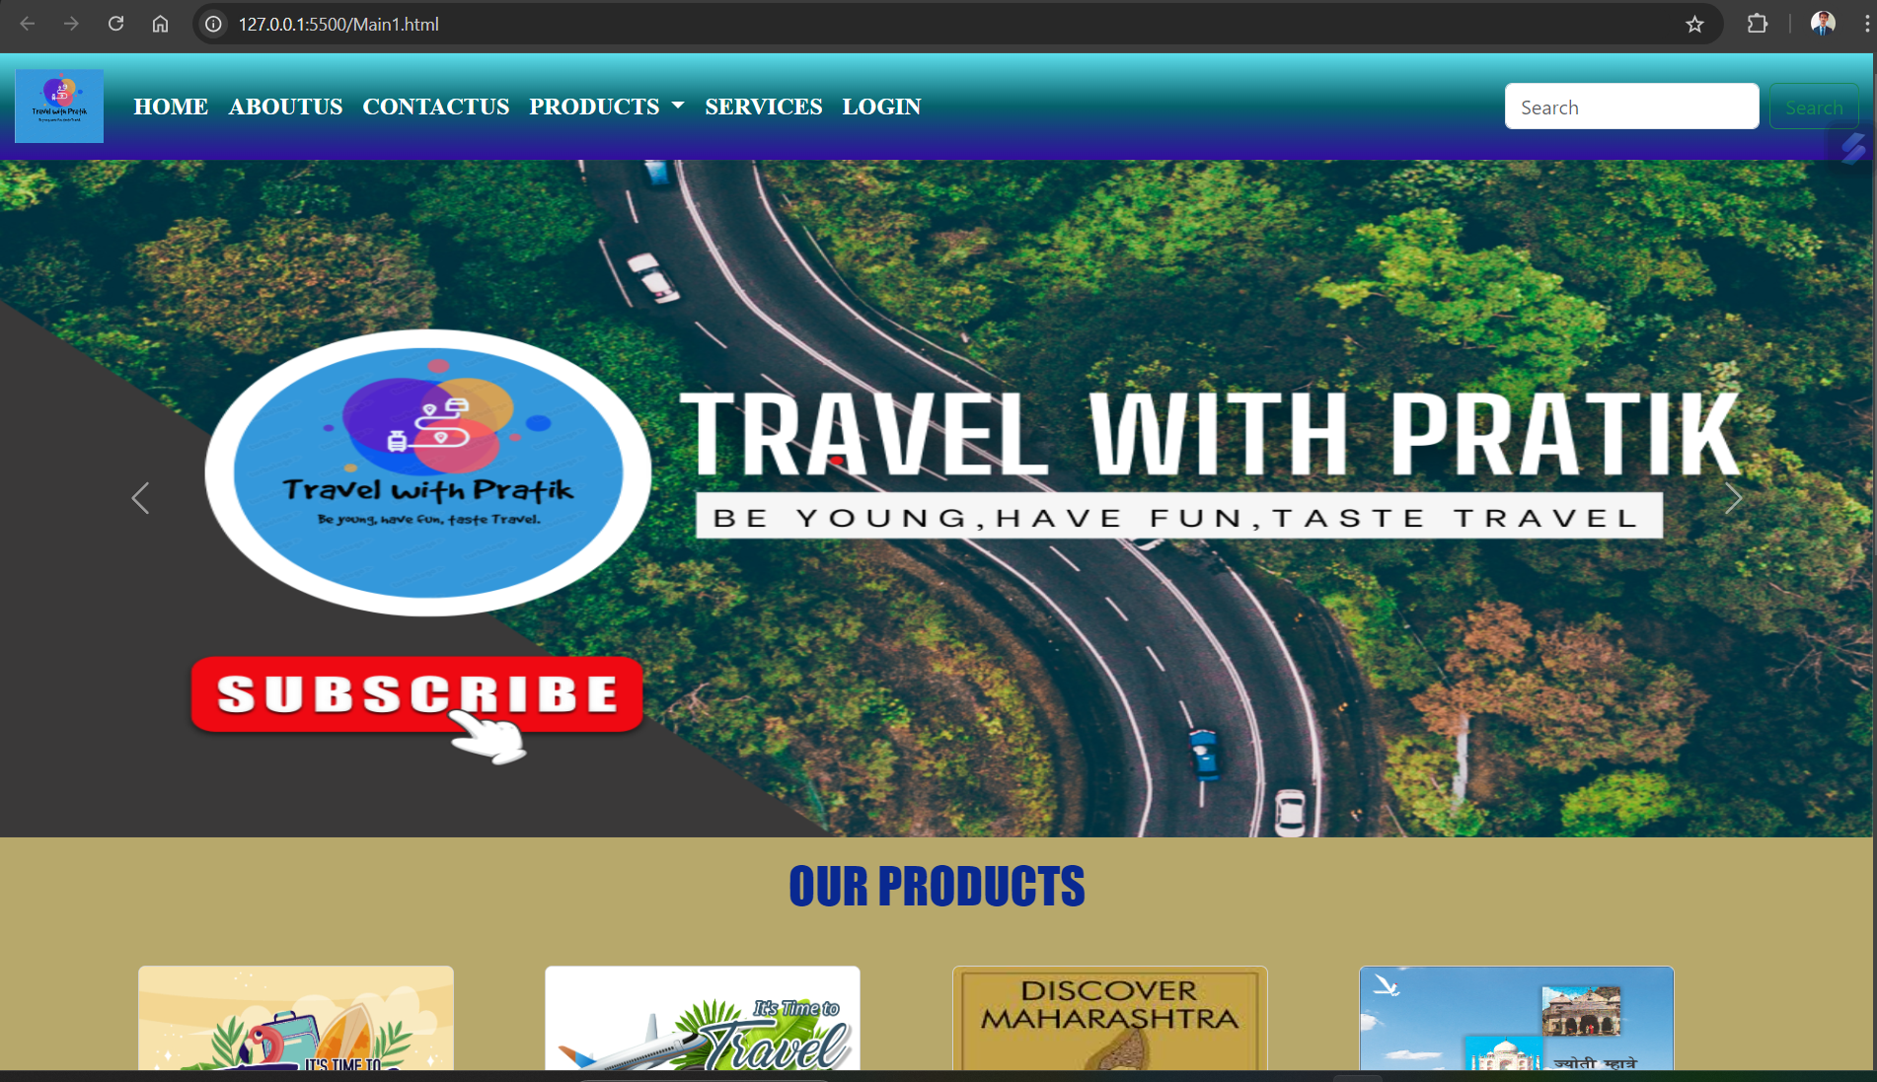

Our Products

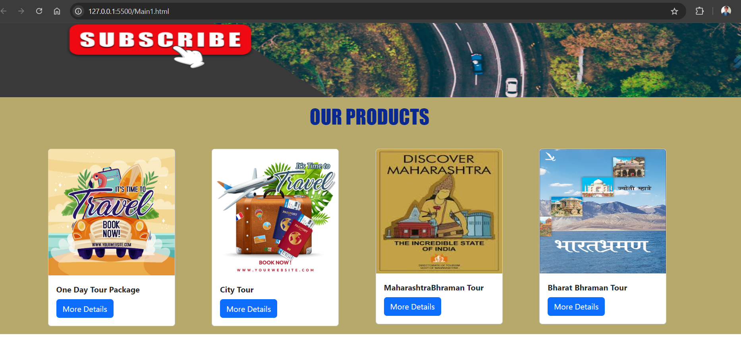

About

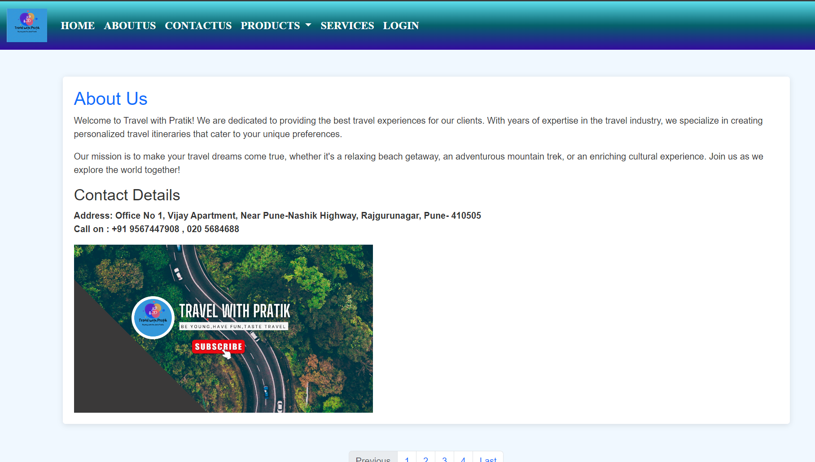

S*ervice*

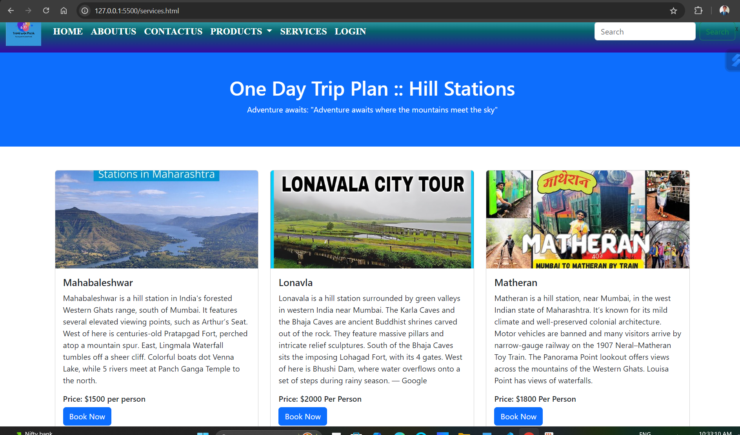

Login page

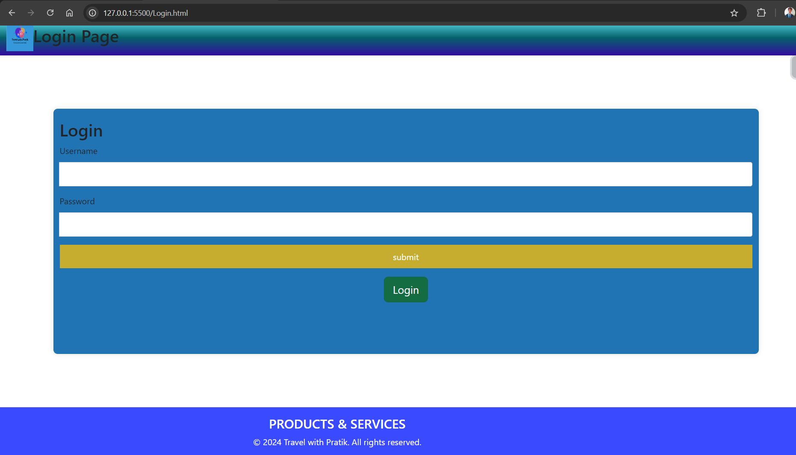

Contact as

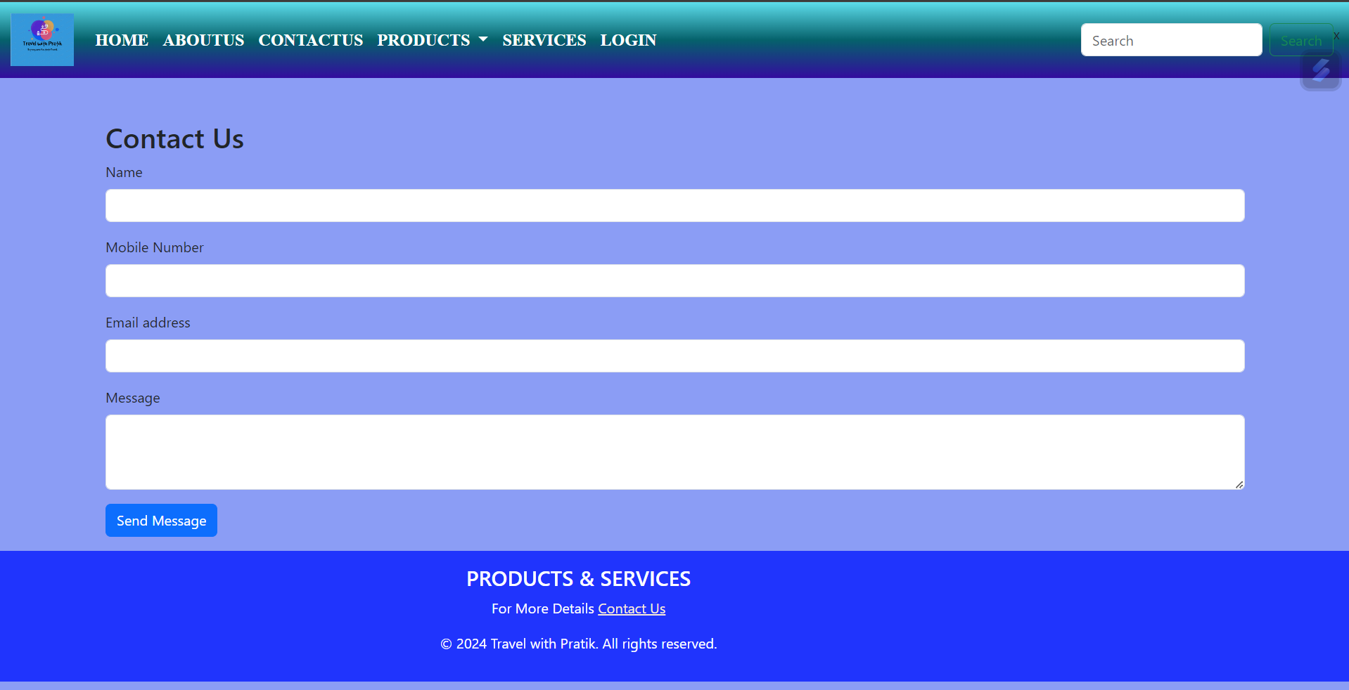

Thank you…..